# DATA8005 – Using the Neo4J Console Tutorials

Using CMD / Command Prompt and CD to you Neo4J bin folder.

Run: neo4j console

In your browser, go to <http://localhost:7474/browser/>

Login using user neo4j and password neo4j. You will be asked to change the neo4j password.

Click on Start Learning.

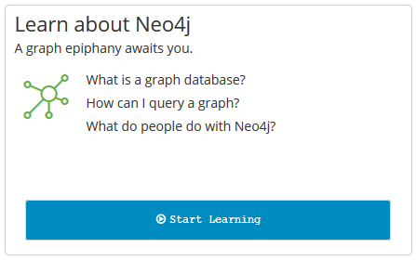

Go through the slides about Graph Fundamentals.

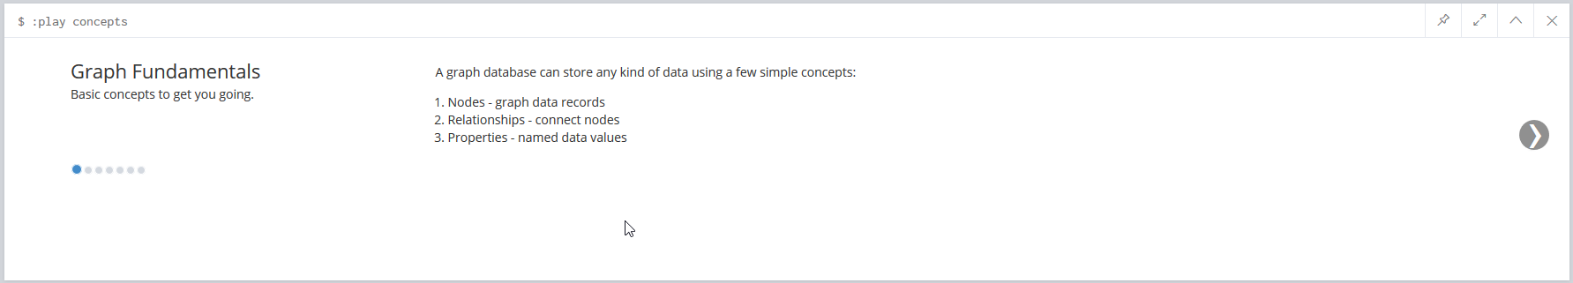

On the last slide, click on Intro (or enter play intro):

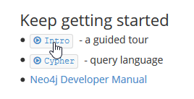

Go through the slides and click on Cypher (or enter play cypher):

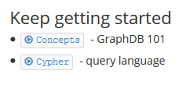

Go through the slides, clicking on the Cypher queries:

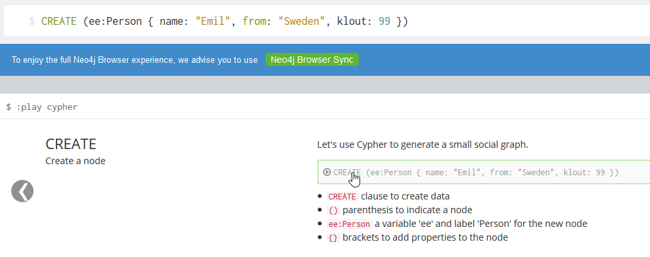

That loads the query in to the query text box. Press enter for each to run them. For multi-line queries, you need to click the play button to the right:

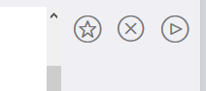

You should see the query results, such as:

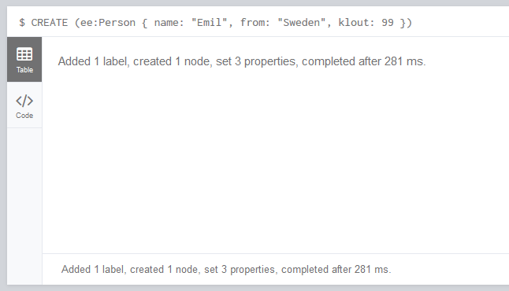

You can close query result windows as you go to declutter by clicking the X:

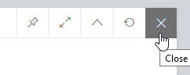

At the end of those sets of slides, click on The Movie Graph (or enter: play movie-graph):

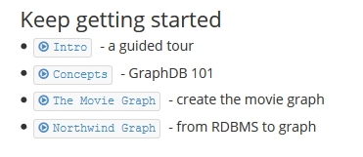

Run the queries on those slides.

You can also explore the Web Console interface. Have a look on the left hand side:

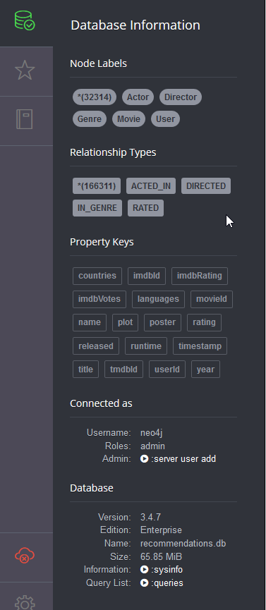

That image shows the sample movie database. Go to <https://neo4j.com/sandbox-v2/> if you want to explore more example database (you will need to create an account, e.g. using your existing Google account).

That ends the tutorial.

The assessment for Cypher will use the data you see in the Tate dataset, e.g. creating relationships between artists and artworks. The assessment specification will direct you to some additional resources on Cypher to help you along.